**ABSTRACT (Paper)**

**Title:** **Ultrasound guided internal jugular vein catheterization in critical care patients: a comparative study with the landmark technique**

**Authors:** Dr Daijy Baruah (Corresponding author), Dr Karuna Kumar Das, Dr Diganta Saikia

**Email:**[daijybaruah32@gmail.com](mailto:daijybaruah32@gmail.com)

**Mobile:**7086858221

**Keywords**: Central venous catheter, internal jugular vein, ultrasound, standard landmark technique.

**Introduction**: Central venous catheterization is crucial in the management of the critically ill patients. Our study was to evaluate whether ultrasound-guided internal jugular vein catheterization is superior to the standard landmark technique.

**Methods**: In this study, 45 critical care patients who underwent ultrasound-guided catheterization of the internal jugular vein were compared with 45 critical care patients in whom the landmark technique was used. Randomization was performed by means of a computer-generatedrandom numbers table, and all patients were stratified with regard to age, sex, and body mass index.

**Results**:There were no significant differences in gender, age, body mass index, side of cannulation, or presence of risk factor for difficult venous cannulation. The persons who performed the procedure had comparable experience. Catheterization of the internal jugular vein was successfully achieved in 95.5% patients by ultrasound-guided technique and in 82.2% by using landmark technique(p=0.044). average access time (skin to vein) and number of attempts were also significantly reduced in the ultrasound group.In the landmark technique group, carotid punctureoccurred in 11.1% of patients, subcutaneous emphysema in 15.5%, hematoma in 17.7%, pneumothorax in 2.2% and central venous catheter associated blood stream infection in 17.7%, which were all significantly increased compared to the ultrasound guided group.

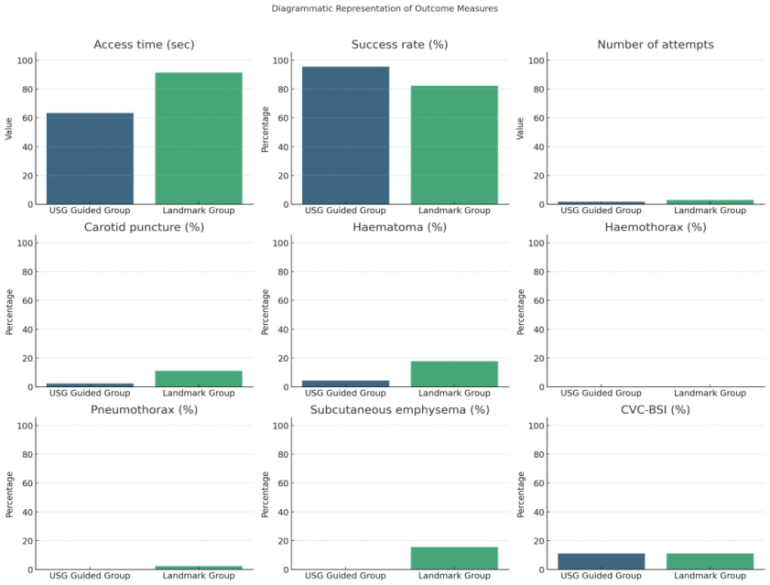**Conclusion**: Our study suggests that ultrasound guided internal jugular vein catheterization in critical care patients is superior to the landmark technique.

Fig: Graphical representation of outcomes of our study in central venous catheterization

**References**:

1. Karakitsos D, Labropoulos N, De Groot E, Patrianakos AP, Kouraklis G, Poularas J, Samonis G, Tsoutsos DA, Konstadoulakis MM, Karabinis A. Real-time ultrasound-guided catheterisation of the internal jugular vein: a prospective comparison with the landmark technique in critical care patients. Crit Care. 2006;10(6):R162. doi: 10.1186/cc5101. PMID: 17112371; PMCID: PMC1794469.
2. Ahmed SS, Samad K, Yousuf MS, Qamar-Ul-Hoda M. A Comparison of Techniques of Internal Jugular Vein Cannulation: Anatomical Landmark, Ultrasound Guided Pre-location, and Real-Time Ultrasound Guided. Cureus. 2024 Feb 19;16(2):e54499. doi: 10.7759/cureus.54499. PMID: 38516452; PMCID: PMC10955425.